DELIVERY ORDER TRACKING SYSTEM

INTRODUCTION
The Delivery Order Tracking System is an automated application designed to help users efficiently manage and track their product deliveries. Traditionally, tracking delivery orders involves manual checking, phone calls, and lack of real-time updates, which can lead to delays and confusion. This project eliminates these challenges by providing a Graphical User Interface (GUI) through which users can log in, view their order details, check delivery statuses, and search for specific orders instantly.
The system ensures smooth interaction between the user interface and the backend database, maintaining accurate order information and status updates in real time. It uses Java Swing for the GUI and MySQL for backend data management, ensuring a user-friendly, secure, and scalable solution.
OBJECTIVES
- To provide an intuitive and user-friendly interface for customers to view and track their delivery orders.
- To allow users to register, log in securely, and access their personalized dashboard.
- To display all delivery orders with their respective statuses such as Pending, Shipped, and Delivered.
- To enable quick search and filtering of orders using the order number.
- To store and manage user and order data efficiently in a MySQL database.
- To minimize manual tracking efforts and enhance the accuracy of delivery information.
- To ensure easy scalability for adding more users and orders in the future.
SYSTEM REQUIREMENTS AND SETUP

Software Requirements
• RAM: Minimum 4 GB
• Processor: Intel Core i3 or higher
• Hard Disk Space: Minimum 100 MB of free space
• Operating System: Windows 10 or above
• Java Development Kit (JDK): Version 1.8 or above
• Database Server: MySQL 8.0 or above
• Integrated Development Environment (IDE): Eclipse IDE
• Libraries Required: MySQL Connector/J (mysql-connector-java.jar)

Hardware Requirements
• Processor: Intel i3 / AMD Ryzen 3 or higher
• Memory: 4 GB RAM (Recommended 8 GB for smooth execution)
• Storage: Minimum 500 MB available for project files and database storage
• Display: 1024×768 resolution or higher for GUI display
• Network: Localhost connectivity for database communication

Setup Instructions
- Create MySQL Database:
CREATE DATABASE delivery_tracking_db;
USE delivery_tracking_db;
- Create Tables:
CREATE TABLE IF NOT EXISTS users (
id INT AUTO_INCREMENT PRIMARY KEY,
username VARCHAR(50) NOT NULL UNIQUE,
password VARCHAR(100) NOT NULL,
email VARCHAR(100),
phone VARCHAR(15),
address VARCHAR(255)
);

CREATE TABLE IF NOT EXISTS orders (
id INT AUTO_INCREMENT PRIMARY KEY,
user_id INT NOT NULL,
order_number VARCHAR(50) NOT NULL,
product_name VARCHAR(100) NOT NULL,
status VARCHAR(50) NOT NULL,
delivery_date DATE NOT NULL,
address VARCHAR(255),
FOREIGN KEY (user_id) REFERENCES users(id)
);
- Import the table structure
Import the provided SQL script (delivery_tracking_db.sql) in MySQL Workbench
- Add the JDBC Connector:
Add mysql-connector-java.jar to the Project Libraries in Eclipse.
(Right-click Project → Build Path → Configure Build Path → Add External JARs → Select the connector file)
- Run the Application:
Open the project in Eclipse.
Start MySQL Server.
Run Main.java to launch the Login Window.
- User Login:
Existing users can log in using their username and password.
New users can register using the Sign-Up option.
- Track Orders:
After logging in, users can view, search, and track their delivery orders.
- Admin Access (Optional):
Admins can log in with admin credentials to view all orders and manage user data.
PROCEDURE

1. User Login and Registration:
- Open the User Login GUI.
- Enter username and password to log in.
- If you are a new user, click Register and fill in details such as name, email, phone, and address.
- On successful login, the user dashboard appears.

2. Viewing and Tracking Orders:
- After logging in, the user can view a list of all their orders.
- Each order displays the Order Number, Product Name, Status, Delivery Date, and Address.
- The order status is:
  - Delivered – Successfully completed.
  - Shipped – Currently in transit.
  - Pending – Yet to be dispatched.
- Users can use the Search Bar to find specific orders by Order Number or Product Name.
- Real-time updates are fetched from the database.

3. Database and Server Interaction:
- The application connects to MySQL using JDBC (mysql-connector-java.jar).
- All login credentials, user data, and order details are securely stored in the database.
- When users perform actions like login or search, SQL queries are executed in real-time.
- The system ensures data integrity and automatic refresh of order status updates.
FLOW DIAGRAM
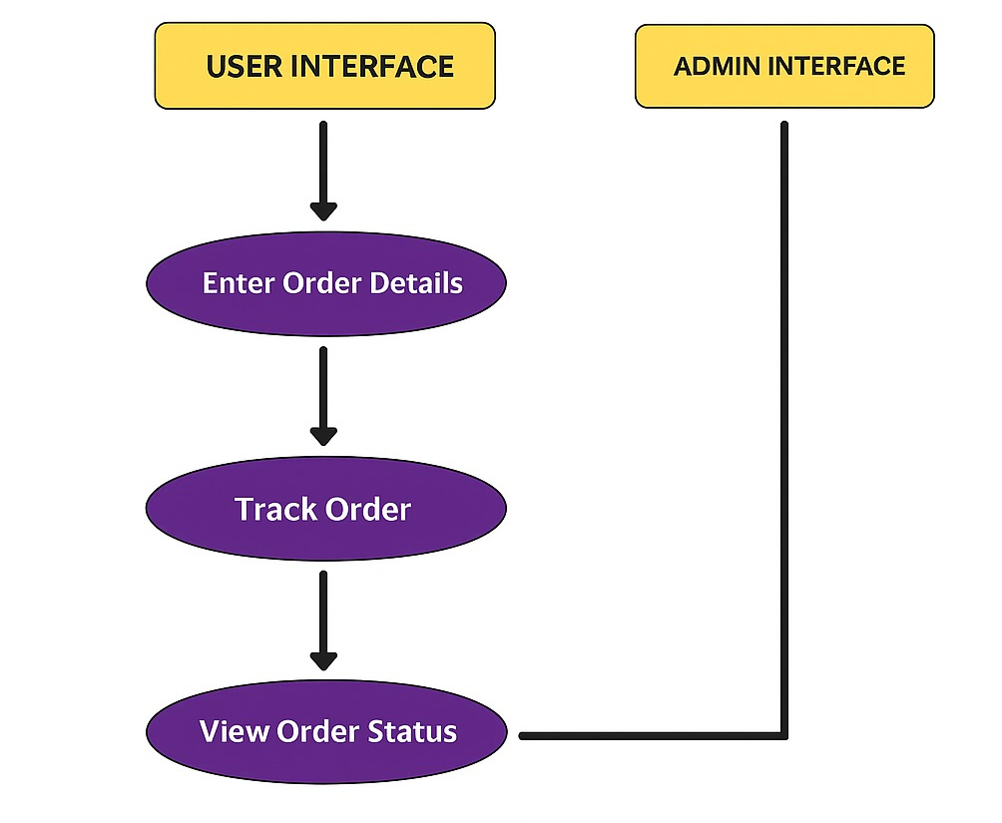

CODE
1.DBConnection.java
package deliverytracking;
import java.sql.*;
public class DBConnection {
static final String URL = "jdbc:mysql://localhost:3306/delivery_tracking_db";
static final String USER = "root"; // your MySQL username
static final String PASS = "Dharrini@123"; // your MySQL password
public static Connection getConnection() {
try {
Class.forName("com.mysql.cj.jdbc.Driver");
return DriverManager.getConnection(URL, USER, PASS);
} catch (Exception e) {
e.printStackTrace();
return null;
}
}
}
2.LoginFrame.java
package deliverytracking;
import javax.swing.*;
import java.awt.*;
import java.awt.event.*;
import java.sql.*;
public class LoginFrame extends JFrame {
JTextField emailField;
JPasswordField passwordField;
JButton loginBtn, registerBtn;

Color bg = new Color(255, 247, 233);
Color btn = new Color(168, 218, 220);
Color hover = new Color(184, 228, 201);

public LoginFrame() {
setTitle("Login - Delivery Tracking");
setSize(420, 300);
setDefaultCloseOperation(JFrame.EXIT_ON_CLOSE);
setLocationRelativeTo(null);
setLayout(null);
getContentPane().setBackground(bg);

JLabel title = new JLabel("User Login", SwingConstants.CENTER);
title.setFont(new Font("Segoe UI", Font.BOLD, 22));
title.setBounds(100, 20, 200, 40);
add(title);

JLabel emailLbl = new JLabel("Email:");
emailLbl.setBounds(60, 80, 100, 25);
add(emailLbl);
emailField = new JTextField();
emailField.setBounds(150, 80, 200, 25);
add(emailField);

JLabel passLbl = new JLabel("Password:");
passLbl.setBounds(60, 120, 100, 25);
add(passLbl);
passwordField = new JPasswordField();
passwordField.setBounds(150, 120, 200, 25);
add(passwordField);

loginBtn = createButton("Login", 80, 180);
registerBtn = createButton("Register", 220, 180);

add(loginBtn);
add(registerBtn);

loginBtn.addActionListener(e -> login());
registerBtn.addActionListener(e -> {
dispose();
new RegisterFrame().setVisible(true);
});
}

private JButton createButton(String text, int x, int y) {
JButton btnX = new JButton(text);
btnX.setBounds(x, y, 120, 35);
btnX.setBackground(btn);
btnX.setFocusPainted(false);
btnX.setBorder(BorderFactory.createLineBorder(Color.LIGHT_GRAY, 1));
btnX.addMouseListener(new MouseAdapter() {
public void mouseEntered(MouseEvent e) { btnX.setBackground(hover); }
public void mouseExited(MouseEvent e) { btnX.setBackground(btn); }
});
return btnX;
}

private void login() {
String email = emailField.getText();
String password = new String(passwordField.getPassword());
System.out.println("Login attempt: " + email + " / " + password);

try (Connection conn = DBConnection.getConnection()) {
if (conn == null) {
JOptionPane.showMessageDialog(this, "Database connection failed!");
return;
}

PreparedStatement ps = conn.prepareStatement(
"SELECT * FROM users WHERE email=? AND password=?"
);
ps.setString(1, email);
ps.setString(2, password);
ResultSet rs = ps.executeQuery();

if (rs.next()) {
int userId = rs.getInt("id");
JOptionPane.showMessageDialog(this, "Login Successful!");
dispose();
new UserDashboard(userId).setVisible(true);
} else {
JOptionPane.showMessageDialog(this, "Invalid credentials!");
}
} catch (Exception ex) {
ex.printStackTrace();
}
}
}
3.RegisterFrame.java package deliverytracking;
import javax.swing.*;
import java.awt.*;
import java.awt.event.*;
import java.sql.*;

public class RegisterFrame extends JFrame {
JTextField nameField, emailField;
JPasswordField passwordField;
JButton registerBtn, backBtn;

Color bg = new Color(255, 247, 233);
Color btn = new Color(168, 218, 220);
Color hover = new Color(184, 228, 201);

public RegisterFrame() {
setTitle("Register - Delivery Tracking");
setSize(420, 330);
setDefaultCloseOperation(JFrame.EXIT_ON_CLOSE);
setLocationRelativeTo(null);
setLayout(null);
getContentPane().setBackground(bg);

JLabel title = new JLabel("Create Account", SwingConstants.CENTER);
title.setFont(new Font("Segoe UI", Font.BOLD, 22));
title.setBounds(100, 20, 220, 40);
add(title);

addLabel("Name:", 60, 80);
nameField = addField(150, 80);

addLabel("Email:", 60, 120);
emailField = addField(150, 120);

addLabel("Password:", 60, 160);
passwordField = new JPasswordField();
passwordField.setBounds(150, 160, 200, 25);
add(passwordField);

registerBtn = createButton("Register", 80, 220);
backBtn = createButton("Back", 220, 220);
add(registerBtn);
add(backBtn);

registerBtn.addActionListener(e -> register());
backBtn.addActionListener(e -> {
dispose();
new LoginFrame().setVisible(true);
});
}

private void addLabel(String text, int x, int y) {
JLabel lbl = new JLabel(text);
lbl.setBounds(x, y, 100, 25);
add(lbl);
}

private JTextField addField(int x, int y) {
JTextField tf = new JTextField();
tf.setBounds(x, y, 200, 25);
add(tf);
return tf;
}

private JButton createButton(String text, int x, int y) {
JButton btnX = new JButton(text);
btnX.setBounds(x, y, 120, 35);
btnX.setBackground(btn);
btnX.setFocusPainted(false);
btnX.setBorder(BorderFactory.createLineBorder(Color.LIGHT_GRAY, 1));
btnX.addMouseListener(new MouseAdapter() {
public void mouseEntered(MouseEvent e) { btnX.setBackground(hover); }
public void mouseExited(MouseEvent e) { btnX.setBackground(btn); }
});
return btnX;
}

private void register() {
String name = nameField.getText();
String email = emailField.getText();
String password = new String(passwordField.getPassword());

try (Connection conn = DBConnection.getConnection()) {
PreparedStatement ps = conn.prepareStatement("INSERT INTO users(name, email, password) VALUES (?, ?, ?)");
ps.setString(1, name);
ps.setString(2, email);
ps.setString(3, password);
ps.executeUpdate();
JOptionPane.showMessageDialog(this, "Registered Successfully!");
dispose();
new LoginFrame().setVisible(true);
} catch (Exception ex) {
JOptionPane.showMessageDialog(this, "Error: Email already exists!");
}
}
}
4.UserDashboard.java
package deliverytracking;

import javax.swing.*;
import javax.swing.table.*;
import java.awt.*;
import java.awt.event.*;
import java.sql.*;
import java.util.Vector;

public class UserDashboard extends JFrame {

private int userId;
private JTable orderTable;
private JTextField searchField;
private DefaultTableModel model;

public UserDashboard(int userId) {
this.userId = userId;
setTitle("User Dashboard - Delivery Tracker");
setDefaultCloseOperation(JFrame.EXIT_ON_CLOSE);
setSize(750, 500);
setLocationRelativeTo(null);
getContentPane().setBackground(new Color(255, 248, 240)); // pastel background
setLayout(new BorderLayout(10, 10));

// Header Panel
JPanel headerPanel = new JPanel(new FlowLayout(FlowLayout.CENTER, 10, 15));
headerPanel.setBackground(new Color(208, 236, 231)); // soft green-blue pastel
JLabel title = new JLabel("📦 My Orders");
title.setFont(new Font("Segoe UI", Font.BOLD, 22));
title.setForeground(new Color(50, 50, 70));
headerPanel.add(title);
add(headerPanel, BorderLayout.NORTH);

// Table
String[] columns = {"Order Number", "Product Name", "Status"};
model = new DefaultTableModel(columns, 0);
orderTable = new JTable(model) {
public boolean isCellEditable(int row, int column) {
return false;
}
};

orderTable.setFont(new Font("Segoe UI", Font.PLAIN, 14));
orderTable.setRowHeight(28);
orderTable.getTableHeader().setFont(new Font("Segoe UI", Font.BOLD, 15));
orderTable.getTableHeader().setBackground(new Color(240, 230, 250));
orderTable.setGridColor(new Color(230, 230, 230));

// Alternate row color
orderTable.setDefaultRenderer(Object.class, new DefaultTableCellRenderer() {
@Override
public Component getTableCellRendererComponent(JTable table, Object value,
boolean isSelected, boolean hasFocus,
int row, int column) {
Component c = super.getTableCellRendererComponent(table, value, isSelected, hasFocus, row, column);
if (!isSelected) {
c.setBackground(row % 2 == 0 ? new Color(255, 250, 245) : new Color(245, 240, 255));
}
// Colored status
if (column == 2) {
String status = value.toString().toLowerCase();
if (status.contains("pending")) {
c.setForeground(new Color(255, 140, 0)); // orange
} else if (status.contains("shipped")) {
c.setForeground(new Color(0, 150, 255)); // blue
} else if (status.contains("delivered")) {
c.setForeground(new Color(0, 150, 0)); // green
} else {
c.setForeground(Color.BLACK);
}
} else {
c.setForeground(Color.DARK_GRAY);
}
return c;
}
});

JScrollPane scrollPane = new JScrollPane(orderTable);
scrollPane.setBorder(BorderFactory.createEmptyBorder(10, 10, 10, 10));
add(scrollPane, BorderLayout.CENTER);

// Bottom Panel (Search + Buttons)
JPanel bottomPanel = new JPanel(new FlowLayout(FlowLayout.CENTER, 15, 10));
bottomPanel.setBackground(new Color(255, 248, 240));

JLabel searchLabel = new JLabel("Search:");
searchLabel.setFont(new Font("Segoe UI", Font.BOLD, 14));
bottomPanel.add(searchLabel);

searchField = new JTextField(20);
searchField.setFont(new Font("Segoe UI", Font.PLAIN, 14));
searchField.setBackground(new Color(255, 255, 255));
searchField.setBorder(BorderFactory.createLineBorder(new Color(200, 200, 200), 1));
bottomPanel.add(searchField);

JButton searchBtn = createButton("🔍 Search", new Color(197, 225, 233));
JButton refreshBtn = createButton("🔄 Refresh", new Color(220, 237, 200));
JButton logoutBtn = createButton("🚪 Logout", new Color(255, 204, 203));

bottomPanel.add(searchBtn);
bottomPanel.add(refreshBtn);
bottomPanel.add(logoutBtn);
add(bottomPanel, BorderLayout.SOUTH);

// Load Orders Initially
loadOrders("");

// Search Button
searchBtn.addActionListener(e -> {
String keyword = searchField.getText().trim();
loadOrders(keyword);
});

// Refresh Button
refreshBtn.addActionListener(e -> loadOrders(""));

// Logout Button
logoutBtn.addActionListener(e -> {
dispose();
new LoginFrame().setVisible(true);
});

// Live Search as you type
searchField.addKeyListener(new KeyAdapter() {
public void keyReleased(KeyEvent e) {
loadOrders(searchField.getText().trim());
}
});
}

private JButton createButton(String text, Color color) {
JButton btn = new JButton(text);
btn.setFont(new Font("Segoe UI", Font.BOLD, 13));
btn.setBackground(color);
btn.setFocusPainted(false);
btn.setBorder(BorderFactory.createLineBorder(new Color(180, 180, 180), 1, true));
btn.setCursor(new Cursor(Cursor.HAND_CURSOR));
btn.setPreferredSize(new Dimension(110, 32));
return btn;
}

private void loadOrders(String keyword) {
try (Connection conn = DBConnection.getConnection()) {
if (conn == null) {
JOptionPane.showMessageDialog(this, "Database connection failed!");
return;
}

String query = "SELECT order_number, product_name, status " +
"FROM orders WHERE user_id = ? " +
"AND (product_name LIKE ? OR order_number LIKE ?)";
PreparedStatement ps = conn.prepareStatement(query);
ps.setInt(1, userId);
ps.setString(2, "%" + keyword + "%");
ps.setString(3, "%" + keyword + "%");

ResultSet rs = ps.executeQuery();

model.setRowCount(0);
while (rs.next()) {
Vector<String> row = new Vector<>();
row.add(rs.getString("order_number"));
row.add(rs.getString("product_name"));
row.add(rs.getString("status"));
model.addRow(row);
}
} catch (Exception ex) {
ex.printStackTrace();
}
}

}
5.Main.java
Package deliverytracking;
import javax.swing.SwingUtilities;

public class Main {
public static void main(String[] args) {
SwingUtilities.invokeLater(() -> new LoginFrame().setVisible(true));
}
}

SCREENSHOTS
LOGIN PAGE
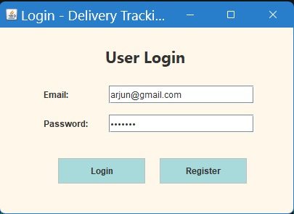
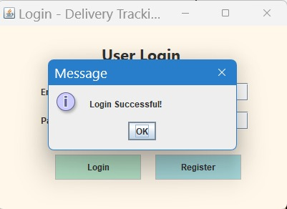
REGISTRATION PAGE
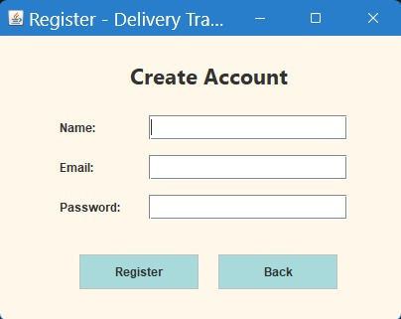
USER DASHBOARD PAGE
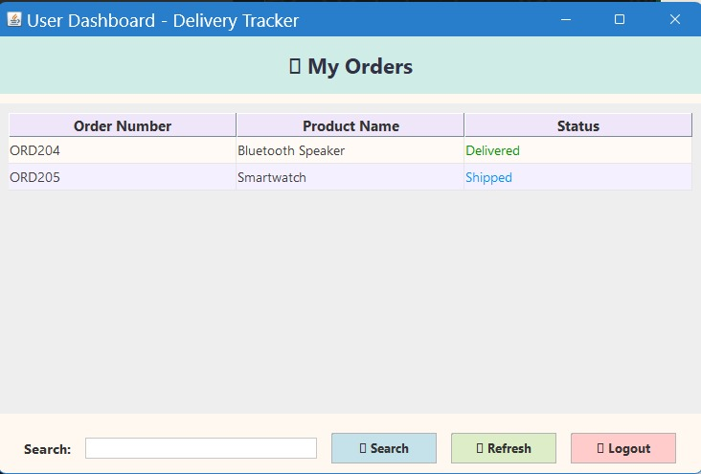
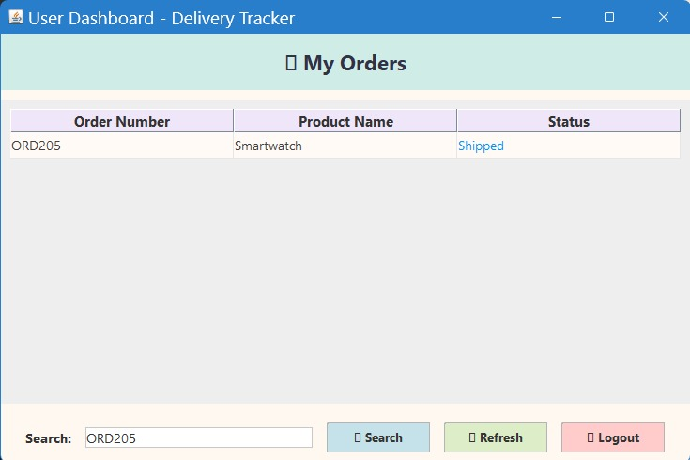

GITHUB REFERENCE
https://github.com/dharrini06/DHARRINI-SELVI-R--DELIVERY-ORDER-TRACKING-SYSTEM

